PROJECT DEVELOPMENT PHASE

SPRINT 1 DELIVERABLES

|  |  |
| --- | --- |
| Team ID | PNT2022TMID54398 |
| Project Name | Smart Fashion Recommender Application |

LOGIN

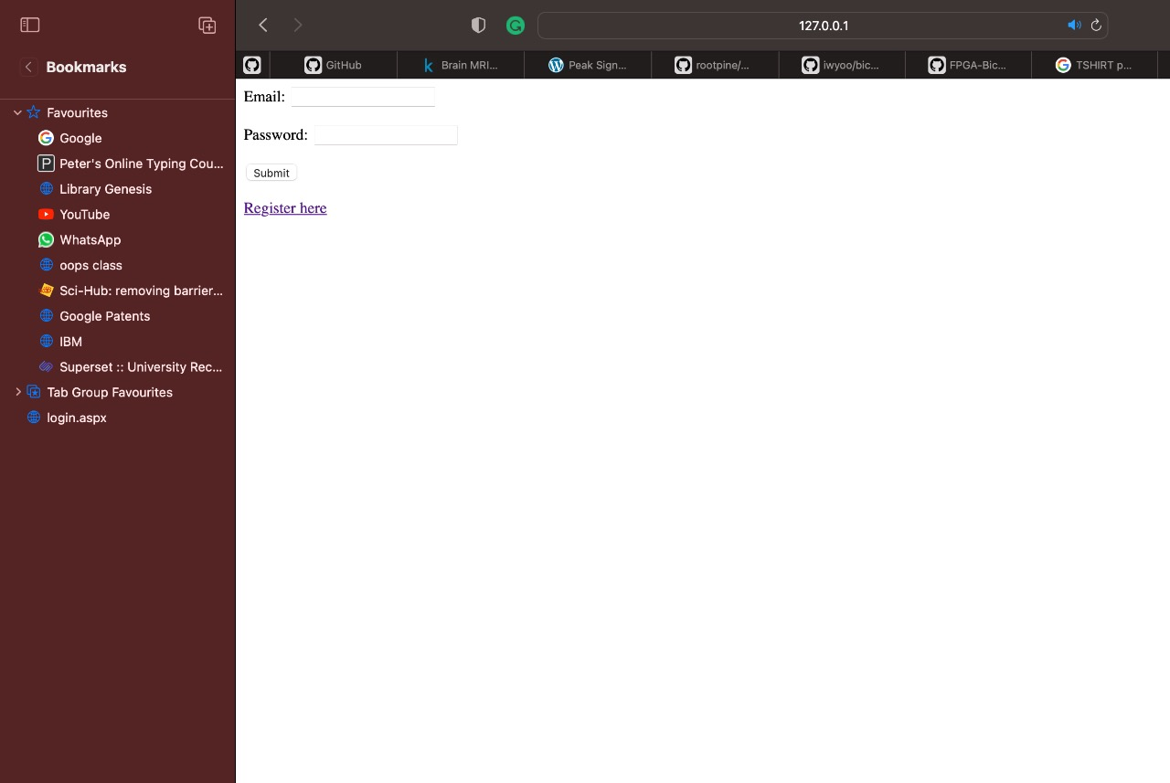

REGISTRATION:

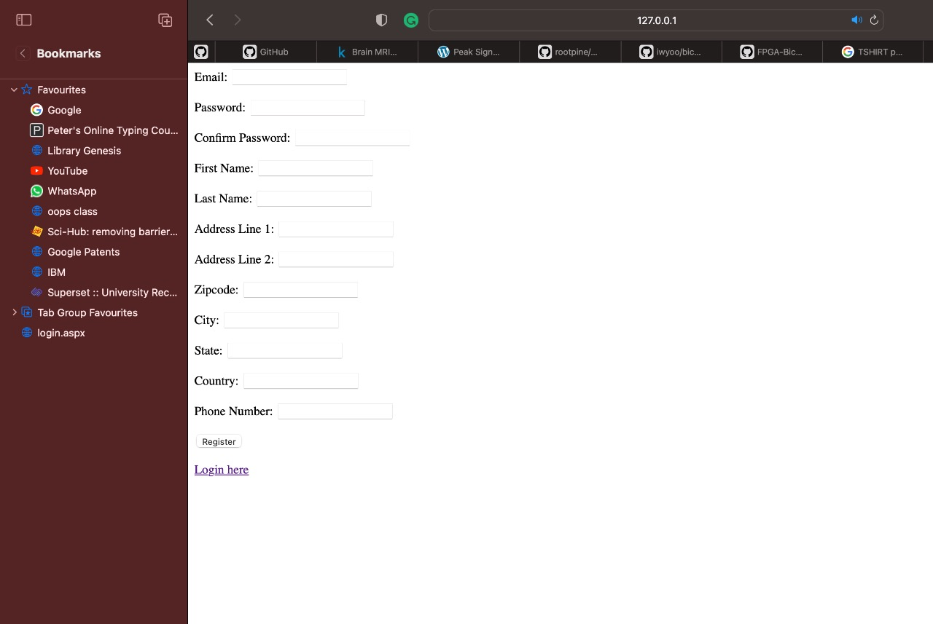

AFTER SUCCESSFUL REGISTRATION DATA IS INSERTED INTO USER TABLE:

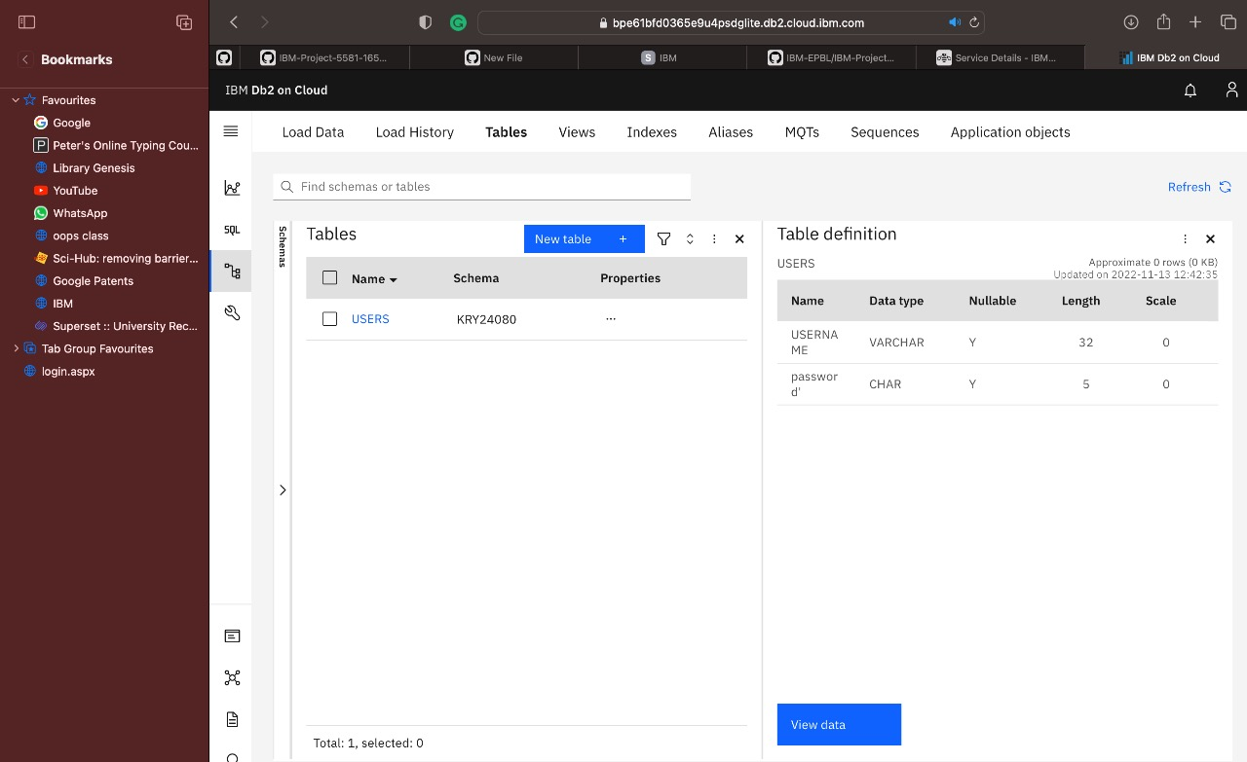

HOME PAGE:

In home page, offers are provided in the carousel.

